Assignment 5 - Measurement Program
The first prompt I used tasked ChatGPT with listing all the metrics used in the 10 papers and identify which ones are described with enough details to be implemented. Using this prompt allowed me to control what metrics ChatGPT would actually try to implement and avoid metrics that would require external tools or too tied to the codebases from the 10 papers. This also allowed me to avoid duplicate metrics used in multiple papers.
Once I have extracted the list of metrics to implement, I directly asked ChatGPT to generate a python code to implement all of them. The generated code saved all the metrics in a large json file. This file contains information about the project codebase metrics, followed by metrics about classes and methods. Since this project can contains information about thousands of classes, reading the file to extract relevant information is better done with a second python code.
Luckily, ChatGPT already included fields in the json file to summarize class and projects metrics without specifically being prompted to. Therefore, I asked ChatGPT for a second python code to extract those summary fields and save them in csv files that I can use to create a dashboard. The generated code saves the information in 3 different csv files that I can use as data sources for my dashboard.
I decided to test these scripts using the pytorch library github. This repository is a large and very active project that is updated every day. The dashboard is created for 5 consecutive days, from the 14th to the 18th of September 2026, and is presented below in chronological order.
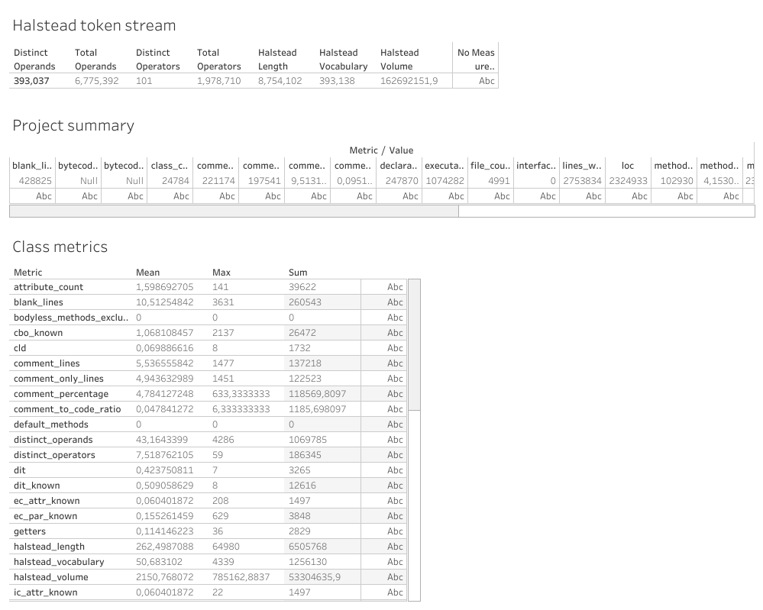
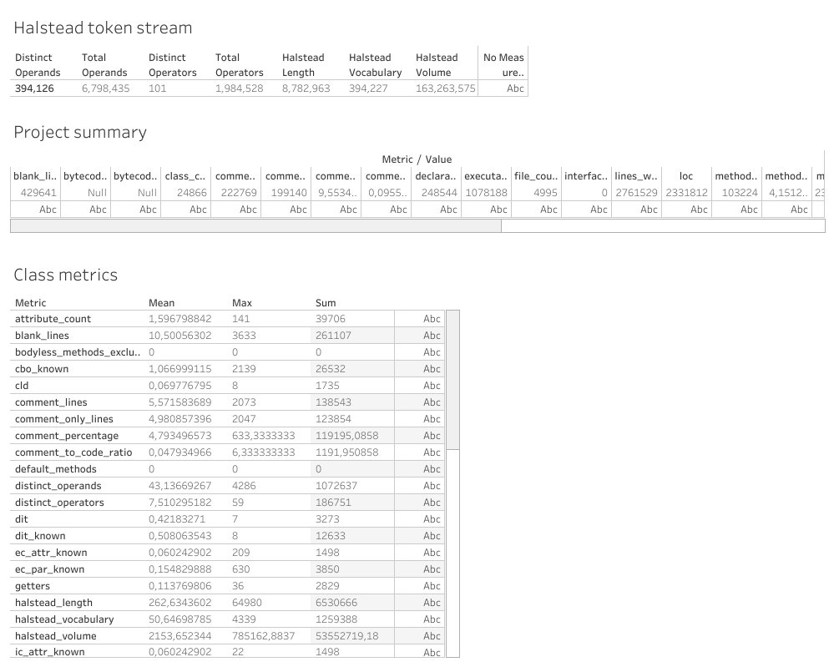
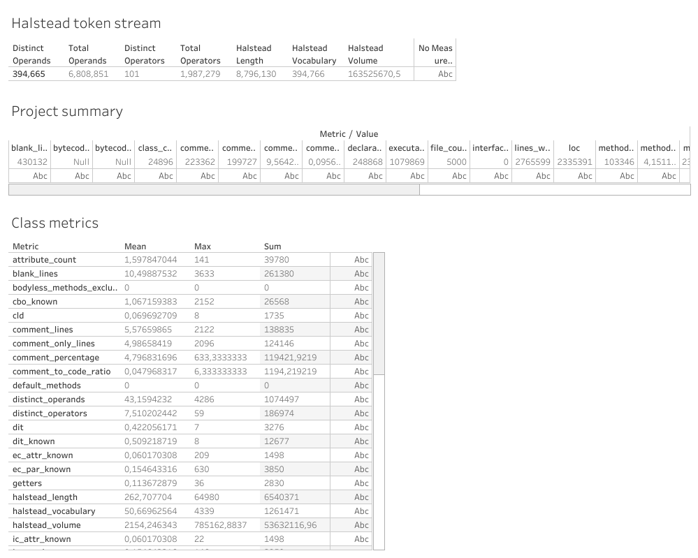
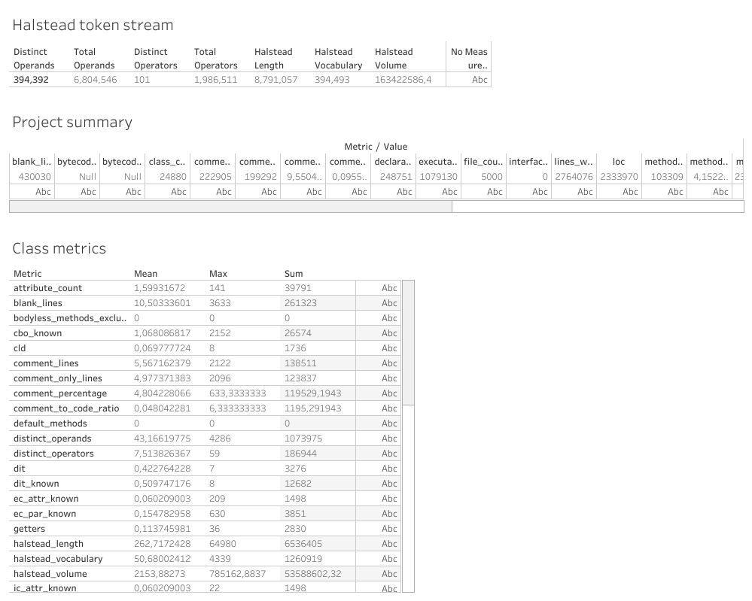
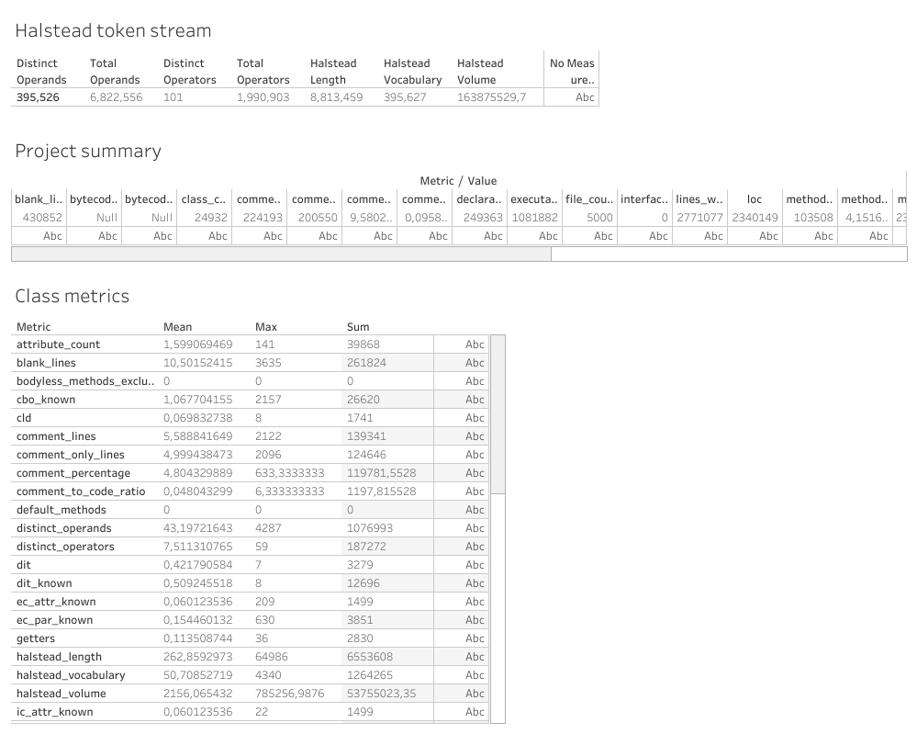
Overall, this set of metrics covers a wide range of software aspects at project, file and method levels. Applying metrics at every level of the project help identifying software issue more clearly and locate where the code needs improvement.
Despite the high amount of metric used, implementing them using ChatGPT was very easy. Going step by step to make sure ChatGPT understand my goal allow for very efficient implementation. The code provided was correct on the first attempt and require no trial and error to improve my prompt. Some metrics were described on a more conceptual level, reliant on some tool specific details, or defined differently between papers. Those metrics can be tedious to implement manually as it needs a good understanding of their goal and how they can be applied to a different code base. However, using ChatGPT made it very easy and fast to implement, saving a lot of time and effort.

